Test Summary Report

Project: ATM Machine

Version : 1.0

TABLE OF CONTENTS

1 Document Controls 3
1.1 Revision History 3
1.2 Distribution List & Document Review 3
2 Introduction 4
2.1 Project Description: 4
2.2 Objective: 4
3 Test Scope 5
3.1 In Scope: 5
3.2 Out of Scope: 5
4 Test Results 6
4.1 Test Execution Details 6
4.2 Any variance to original Test Plan 6
5 Quality of Software 7
5.1 Test Coverage and results 7
5.2 Defect Metrics – by Defect Type 8
5.3 Exit Criteria 9
6 Knowledge Maintenance 10
6.1 Causal Analysis and Resolution 10
6.2 Lessons Learnt 10
6.3 Best Practices Adopted & New Improvements Implemented 10

Document Controls

Revision History
Version | Date | Author | Summary of Changes
0.1 |  |  | Original draft

Distribution List & Document Review
Role | Name | Date | Remarks
Test Manager | Pankaj Bhambhani | 28-08-20 | checked
Test Lead | Sandeep Kale | 21-08-20 | checked
Test Engineer | Samruddhi Naik | 19-08-20 | checked

Reviewed By (Role) | Name | Date | Remarks
Stakeholder 1 | ABCD Bank CEO | 28-08-20 | checked

Introduction

Project Description:
This project is of creating ATM machine for ABCD Bank, this ATM machine will be used by bank customers who have valid ATM cards to withdraw cash.

Objective:
The purpose of the document is:
- To show status against test and quality targets at the completion of Sprint#1
- To provide stakeholders with risk assessment data, which supports the decision to proceed with the release of the tested version of the application.

This report will:
- Summarise the test approach.
- Summarise what was tested and what was not tested according to plan.
- Outline any additional testing done that was not planned to do (and why).
- Summarise the test results.
- Explain any anomalies, such as moving to another test stage without completing exit criteria.
- Determine whether testing has been satisfactorily completed

- Summarize Issues, Mitigation, Lessons Learnt.

Test Scope

In Scope:
REQUIREMENT INFORMATION
ID | CATEGORY | REQUIREMENT | PRIORITY
REQ-001 | Mandatory | Unauthorized/Authorized cards should work appropriately | High

Out of Scope:
ID | CATEGORY | REQUIREMENT | PRIORITY
REQ-002 | Mandatory | User should have ability to quit any time in between the transaction. | High
REQ-003 | Mandatory | ATM should have facility to accept valid PIN from user | High
REQ-004 | Should have | ATM Home screen should show the name of user whose account is linked to ATM card | High
REQ-005 | Should have | ATM should have ability to clear the user input | Medium
REQ-006 | Nice to have | UI should greet welcome message based on day time. | Low
REQ-007 | Nice to have | ATM should show appropriate error in case of internet issues or server problems | Medium

Test Results

Test Execution Details

Test Cycle# | Timelines | Actual Finish Date | Status | Remarks
Cycle 1 | 11/08/2020 -19/08/2020 | 17/08/2020 | Not Completed | 2 features have not been tested yet

4.2 Any variance to original Test Plan
- In Cycle# 1 all the designed test cases couldn’t be executed as they are not given for testing.

Quality of Software

Test Coverage and results
Test Cycles | Total Number of Test Cases | # of Test Cases Executed | # of Test Cases Passed | # of Test Cases Failed | # of Test  Cases  Blocked
Cycle# 1 | 7 | 5 | 1 | 4 | 2
Total # TCs | 7 | 5 | 1 | 4 | 2

Defect Metrics – by Defect Type

Defect in Phase | High | Medium | Low | Lowest | Total
Cycle# 1 | 4 | 0 | 0 | 0 | 4
Totals | 4 | 0 | 0 | 0 | 4

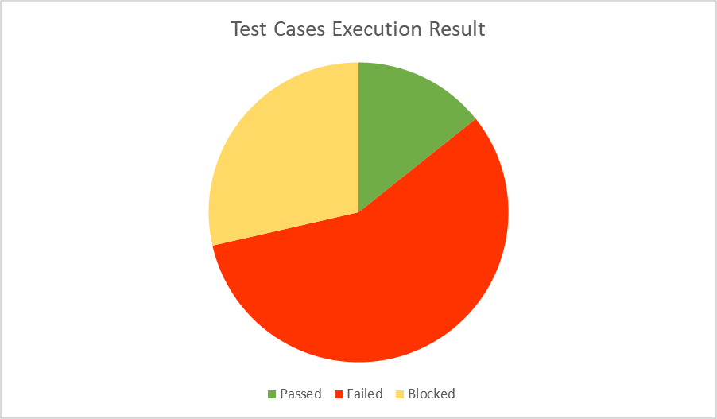

Exit Criteria
Criteria | Met/Not Met
All planned test cases have been executed in Execution Tool | Not Met
All defects found have been recorded in the Defect Management Tool | Met
All Severity High defects have been resolved | Not Met
Test summary Report issued to stakeholders | Not Met

Knowledge Maintenance

Causal Analysis and Resolution
- Few test cases got delayed because of unavailability of test data
Resolution: Gathering of test data should start immediately after test designing

Lessons Learnt

 | Lessons Learnt from Application Sprint# 1
1. | Knowledge of all the cases in which ATM card is unauthorized is required.
2. | Whenever there is any new requirement or update, it should be clearly updated in Tool and those updates should be shared to dev and QA team via mail.

Best Practices Adopted & New Improvements Implemented

- QA Team performed Peer review of Test Cases for each Sprint which helps in better test coverage.
- QA team involved Development team to provide review comments on test cases.
- QA team member is attending daily development scrum calls for seeking clarifications & inputs.

